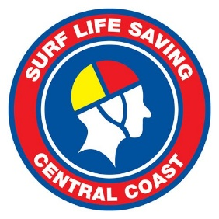

m

Circular 1547 - AMENDED

SLSCC Team Carnival – Umina – 27th of November 2022

Audience: Club Team Manager and interested members.
Date: Monday 14th November 2022
Contact: Michael Hyslop
Phone: 0466 691 090
Email: admin@slscc.com.au
Summary | This circular outline the information related to the ‘SLSCC Team Carnival’ being held on the 27th November 2022.
Action | Clubs are asked to give the information to the appropriate club member responsible for entering carnivals and circulate the below program to interested members.  Program available at:  Carnival Programs - Surf Life Saving Central Coast (slscc.com.au)

Carnival Details
SLSCC will be conducting a “Team Carnival” for U8 to U14 competitors. This carnival consists of only team events.
Location: Umina SLSC
Date: 27^{h} of November 2022
Time: 7:00am: R and R, 7:45am: March Past, 8:00am: All Age Relays, 8:45am: Full Carnival Commences.

Carnival Program
A carnival program is available at; Carnival Programs - Surf Life Saving Central Coast (slscc.com.au)

Entry Cost
$16.50 (including GST) for all competitors.

Live Heats
Live heats WILL NOT be used for this carnival.

Entry Process
Entries are to be completed via the SEMS online sports management platform by a club representative. The carnival in SEMS is listed as “2022/23 SLSCC Nipper Teams Carnival – Umina"
If your club has issues with SEMS access, please contact the SLSA Help Desk for assistance – https://help.sls.com.au/
Entries Open: Wednesday the 16th of November 2022 @ 5:00pm
Entries Close: Wednesday the 23rd of November 2022 @ 9:00am
NO LATE ENTRIES WILL BE ACCEPTED.

Entering Competitors
All competitors attending the carnival are to be entered into the following event at a minimum:
Contest Name: ‘ALL COMPETITORS ENTER THIS EVENT’
This event is also to be used to enter competitors attending the carnival for composite teams only.
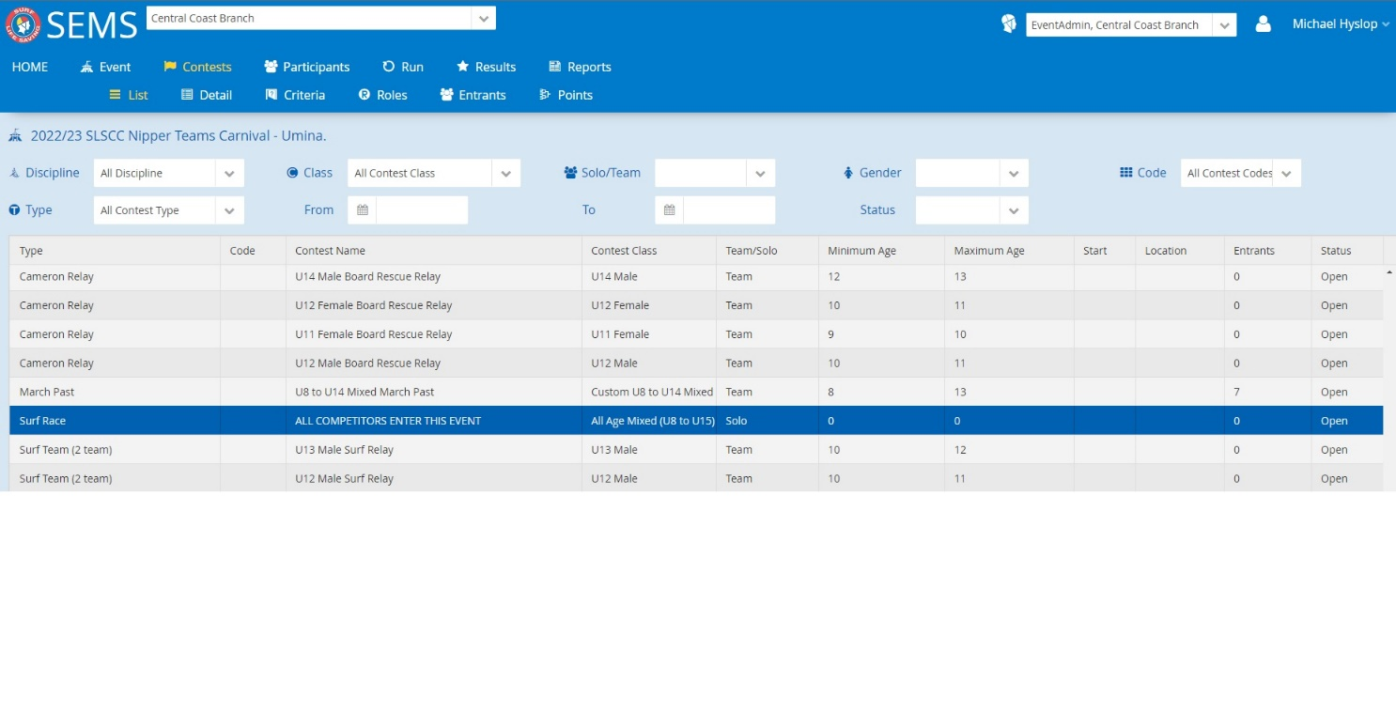
Competitors can also be entered into their respective teams but as a minimum, must be entered into the above mentioned event. This event is the only solo event listed within the SEMS event file and will be easy to find. The purpose of this event is to check competitor eligibility and allow SLSCC to invoice clubs correctly.

Event Explanations and Rules

All Age Relays
U9 to U14 All Age Board and sprint relays will be contested to open the carnival.
Teams consist of 6 competitors with 1 competitor per age group.
There are no gender restrictions on the event. Teams can consist of all female or all male competitors.
All Age Board Relay will be running in order of youngest to oldest competitor.
There is no restriction of order on the All-Age Sprint Relay.
Competitors can compete up a maximum of 1 age group in the All-Age Relays. In the all age board, competitors competing up an age group can’t change craft. E.g. a U10 foamie competitor can’t ride a fibreglass nipper board as an U11 competitor.

Surf Relay
2 competitors per team.
1 ‘swimmer’ completes the course, runs up to the changeover area and tags 2nd ‘swimmer’ who completes the course.

Board Relay
3 competitors per team.
Traditional 3-person board relay.

Brace Relay
2 competitors per team.
1 x swimmer and 1 x board paddler.
1 ‘swimmer competes the course, runs up to the changeover area and tags the ‘board paddler’ who completes the course.

Board Rescue Relay
4 times competitors per team. 2 x swimmers and 2 x board paddlers.
2 competitors complete full board rescue course. Competitor 1 swims to can, raises arm. 2nd competitors paddles board out to “rescue” competitor 1. Competitor 1 and 2 return to shore on the board together.
When competitors 1 and 2 cross the line, competitors 3 and 4 complete the above process.

Sprint Relay – Single Gender
Traditional 4-person sprint relay.

Sprint Relay – Mixed
Traditional 4-person sprint relay with 2 male and 2 female competitors.

2 x 1km and 2 x 500m Sprint Relays
2 competitors per team.
1 x competitor completes course, tags 2nd competitor who completes course.

Composite Teams
Two or more clubs combining to form a team is allowed and encouraged at this carnival.
Composite teams are only allowed if a club doesn’t have sufficient competitors entered into the carnival to form a team.
Competitors wishing to compete in composite teams are to report to marshalling for each event where SLSCC officials will form composite teams.

For any additional information then please contact Michael on the details below.
Michael Hyslop - Surf Sports Officer - Surf Life Saving Central Coast
P 02 4353 0299 M 0466 691 090 E admin@slscc.com.au

